OPT-X6
instructions manual

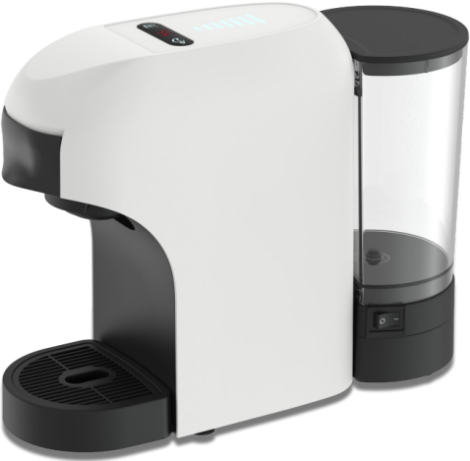
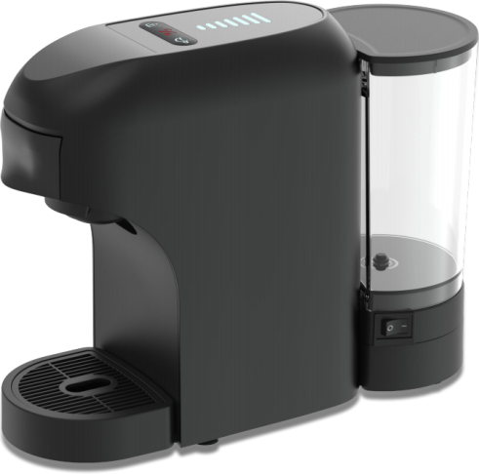


EN instructions manual

MACHINE OVERVIEW



2
1

3


4

8


5

9


6


11
10

7

1. Volume light
2. Start/Stop Button
3. Hot /cold mode Button
4. Volume selector Button
5. Locking handle
6. Drip grid (removable)
7. Drip tray (removable)
8. Water tank cover
9. Water tank
10. Power cord
11. Switch on/off
14


12. Dolce Gusto®* capsule holder
13
12
13. Nespresso®* capsule holder
14. Coffee ground holder
1

SAFETY PRECAUTIONS

SAFETY INSTRUCTIONS
If the supply cord is damaged it must be replaced by the manufacturer, its service agent or similarly qualified persons in order to avoid a hazard.
This appliance can be used by children aged from 8 years and above if they have been given supervision or instruction concerning use of the appliance in a
Safe way and if they understand the hazards involved.Children shall not play with the appliance.
Cleaning and user maintenance shall not be made by children unless they are
older than 8 and supervised. Keep the appliance and its cord out of reach of children aged less than 8 years. Appliances can be used by persons with reduced
physical, sensory or mental capabilities or lack of experience and
knowledge if they have been given supervision or instruction concerning use of the appliance in a safe way and understand the hazards involved.
This appliance is intended to be used in household. It is not intended to be used in applications such as:
- Staff kitchen areas in shops, offices and other working environments.
- Farm houses.
- By clients in hotels, motels and other residential type environments.
- Bed and breakfast type environments.
Proceed according to maintenance and cleaning section of this manual for cleaning. Never immerse the appliance in water or any other liquid.
During brewing and after use due to esidual heat some parts of the machine are hot.
Warning: potential injury from misuse!
This device is designed for use at a maximum altitude up to 2000m above sea level.

IMPORTANT WARNINGS
Any incorrect use or improper handling of the productshall render the warranty null and void. Prior to plugging in the product, check that your mains voltage is the same as the one indicated on the product label. The mains connection cable must not be tangled or wrapped around the product during use. Do not use the device, or connect and disconnect to the supply mains with the hands and / or feet wet. Do not pull on the connection cord in order to unplug it or use it as a handle. Never use your coffee machine without water in it. Unplug the product immediately from the mains in the event of any breakdown or damage and contact an official technical support service. In order to prevent any risk of danger, do not open the device. Only qualified technical personnel from the brand´s Official technical support service may carry out repairs or procedures on the device.
Disclaims all liability for damages that may occur to people, animals or objects, for the non-observance of these warnings.

FIRST USE


STARTING THE MACHINE
Place the coffee machine on a flat and stable surface, far from water and heat sources. Do not connect the machine to the mains supply.
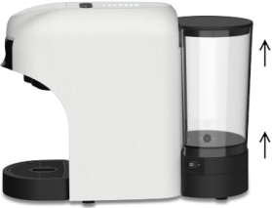
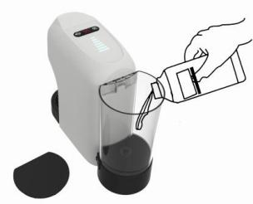
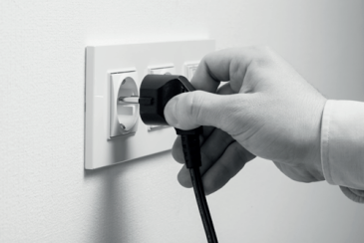
1. Rinse the water tank before filling with drinking water up to maximum level. Plug machine into the mains.
 Hot water and other liquids can damage the tank and the machine. Do not operate the machine without water: make sure that there is enough water in the tank.
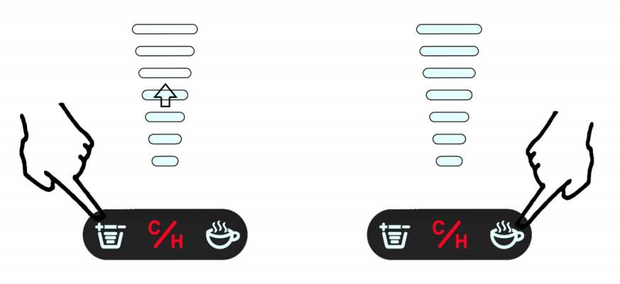
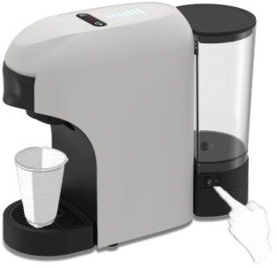



blinking
heating-up
Heating completed

2. Press "switch ON/OFF" button to switch the machine on.
3. Pressing any buttons. The coffee machine strats the heating cycle.The "Hot mode button" start blinking to a light red. (heating-up about 30 sec)
4. The machine will be ready for use when the "Hot mode button" light up to a steady red light and the "start button" light up to a steady white light
5. Rinse the machine by placing a container under the coffee outlet .
6. Repeatedly press the volume selector button to 7th gear, then press the star button.Repeat three times.
 At first power-on, supple at least 0.5L of water without capsule placing a container under coffee spout.
 STAND-BY FUNCTION
To ensure the energy conservation the machine automatic passes to the stand- by mode after 9 min use of not being used.
The machine can be reactivated by pressing the any buttons again.

COFFEE PREPARATION

COFFEE DISPENSING
Make sure that the start buttons lights to a steady white light. Never put fingers or
object in the capsule holder. Only compatible capsules must be introduced in the capsule holders. Single-dose capsules are prepared to dispense one coffee/product. Do not use the capsules more than once. Inserting two or more capsules can cause the machine to malfunction.
For coffee powder choice, please use the spoon to measure the quantity to add to the coffee ground holder. Maximum quantity is about 8g.
Note: Please make sure there are no rest of coffee powder in the inner edge of the holder. This may don’t allow to close the lid properly and may cause trouble to introduce it in the machine.
If power supply is interrupted during the coffee supply cycle, restore power supply and restart the coffee supply procedure. If during the supply cycle water lacks in the tank, please press stop button to stop the machine. Then proceed as follows:
Fill the water tank up to the Max level indicated. Press the start buttons.


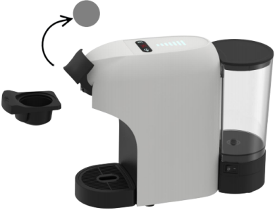
2
1

1) Open locking handle and pull out the capsule holder


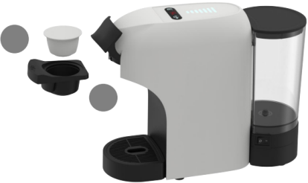
 3
1
2

2) Insert the capsule in the capsule holder (Or add coffee powder in the coffee ground holder) and insert it back in the machine.
Close the locking handle.

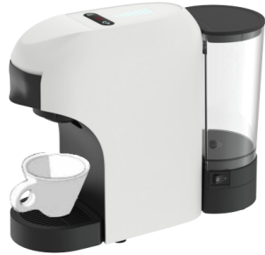
3) Place the cup under the coffee dispenser for a classic espresso

or

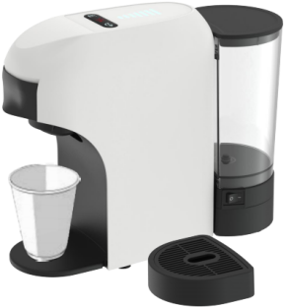
Remove the drip tray to use cups of different sizes for a long coffee

COFFEE PREPARATION

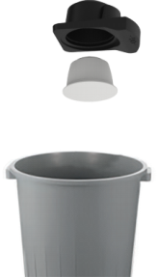


blinking
heating-up
Heating completed
4) Indicator light starts blinking red while machine is heating up for approximately 30 seconds.
5) Afterwards indicator lights steady white the machine is ready to be used.
6) Use the volume selector to set the volume display in accordance with the number of bars shown on capsule or select amount of bars to your own taste.
7) Pressing the start button, beve-rage preparation starts. Wait to stops.
8) Extraction can be stopped at any time manually by pressing the start button.
9) When the machine stops brewing, open the locking handle.
Pull out the capsule holder and remove used capsule. Dispose the capsule properly.
10) Rinse both sides of the capsule holder with water and dry. Inset capsule holder into machine. Enjoy your beverage.

COLD MODE

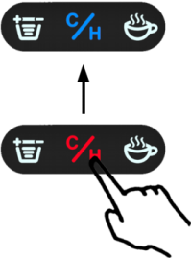
Press the "Hot / Cold mode

button" change to Hot or Cold mode.

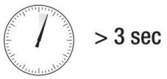
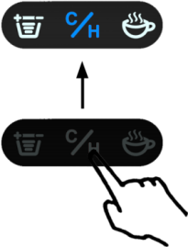
Please press and hold the "Hot / Cold mode" button for 3 seconds, The machine will go directly to Cold mode when powered off.

When in Cold mode, "Hot / Cold mode button" light turns blue and stays on constantly. When in Hot mode, "Hot / Cold mode button" light turns red and start blinking to a light.
Cold mode: The machine does not heat up and uses room temperature water.
When transitioning from hot water mode to cold water mode, "cold water" does not come out immediately, because the inside of the machine is hot, so the first half of the machine is hot water, and it slowly cools down to room temperature water.

MAINTENANCE AND CLEANING

DESCALING
1. Remove and empty the water tank.
2. Refill the tank with a descaling solution and water as specified on the package of the descaling product. Refit the tank.
3. Power the machine On and place a suitable container under the spout.
4. Press brewing buttons and then supply two cups (aprox 150ml each) of water.
5. Allow the descaling solution to work for about 15-20 minutes.
6. Switch on the machine pressing brewing buttons, then proceed as described in steps.
7. Repeat the steps described in point until the water tank is completely empty.
8. Remove the tank and rinse it with fresh drinking water. Fill it completely.
9. Switch the machine on by pressing brewing buttons. Place a suitable container under the dispenser. Press brewing buttons, then supply the full content of the tank.
10. When the water is finished, refill the tank and repeat the steps described in point. When finished, the end of the descaling cycle is completed.

MAINTENANCE AND CLEANING
Do not forget to remove the plug from the socket before cleaning the appliance.
Wipe outside with soft dry cloth when coffee machine is wet, never use metal polish. The removable items should be washed in hot soapy water. Rinse them before fixing.
Never use a dishwasher to clean any parts from the machine. Put the coffee maker in a dry and not very hot place.

PRODUCT DISPOSAL
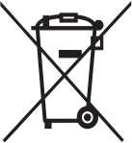
This product complies with European Directive 2012/19/EU on electrical and electronic devices, known as WEEE (Waste Electrical and Electronic Equip- ment), provides the legal framework applicable in the European Union for
the disposal and reuse of waste electronic and electrical devices. Do not dispose of this product in the bin, instead going to the electrical and
electronic waste collection centre closest to your home.

