3 IN 1 COFFEE MAKER
INSTRUCTION MANUAL
BC5370

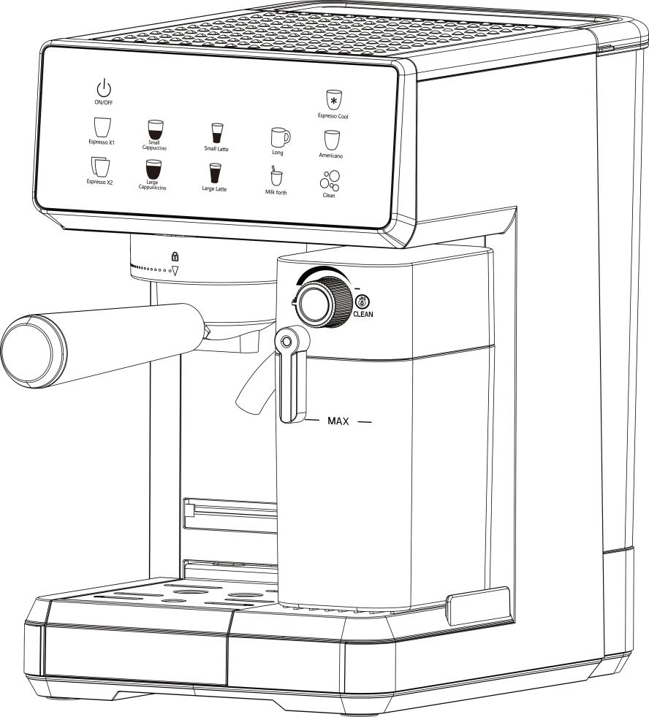

Before operating this unit, please read the instructions completely

IMPORTANT SAFEGUARDS
Before using the electrical appliance, the following basic precautions should always be followed including the following:
1. Read all instructions.
2. Before using check that the voltage of wall outlet corresponds to rated voltage marked on the rating plate.
3. This appliance has been incorporated with a grounded plug. Please ensure the wall outlet in your house is well earthed.
4. To protect against fire, electric shock and injury to persons do not immerse cord, plug, in water or other liquid.
5. Remove plug from wall outlet before cleaning and when not in use. Allow appliance cool down completely before taking off, attaching components or before cleaning.
6. Do not operate any appliance with a damaged cord or plug or after the appliance malfunctions, or is dropped or damaged in any manner. Return appliance to the nearest authorized service facility for examination, repair or electrical or mechanical adjustment.
7. The use of accessory attachments not recommended by the appliance manufacturer may result in fire, electric shock or injury to persons.
8. Place appliance on flat surface or table, do not hang power cord over the edge of table or counter.
9. Ensure the power cord do not touch hot surface of appliance.
10. Do not place the coffee maker on hot surface or beside fire in order to avoid to be damaged.
11. To disconnect, turn any control to “OFF” then remove plug from wall outlet. Always hold the plug. But never pull the cord.
12. Do not use appliance for other than intended use and place it in a dry environment.
13. Close supervision is necessary when your appliance is being used by or near children.
14. Be careful not to get burned by the steam.
15. Do not touch the hot surface of appliance (such as steam wand, and the steel mesh just boiling). Use handle or knobs.
16. Do not let the coffee maker operate without water.
17. Scalding may occur if the water reservoir is removed during the brewing cycles.
18. Do not remove the metal funnel when appliance in brewing coffee or when steam and hot water escape from metal funnel before removing metal funnel.
19. Connect plug to wall outlet before using and turn any switch off before plug is removed from wall outlet.
20. Relief pressure through steam wand before removing reservoir cover or metal funnel.
21. This appliance is not intended for used by persons (including children) with reduced physical, sensory or mental capabilities, or lack of experience and knowledge, unless they have been given supervision or instruction concerning use of the appliances by a person responsible for their safety.
22. Children should be supervised to ensure that they do not play with the appliance.
23. This appliance is intended to be used in household and similar applications such as:
– staff kitchen areas in shops, offices and other working environments;
– farm houses;
– bed and breakfast type environments.
24. Do not use outdoors.
25. Do not place on or near a hot gas or electric burner, or in a heated oven.
26. Save these instruction.

KNOW YOUR COFFEE MAKER
(Product may be subject to change without prior notice)

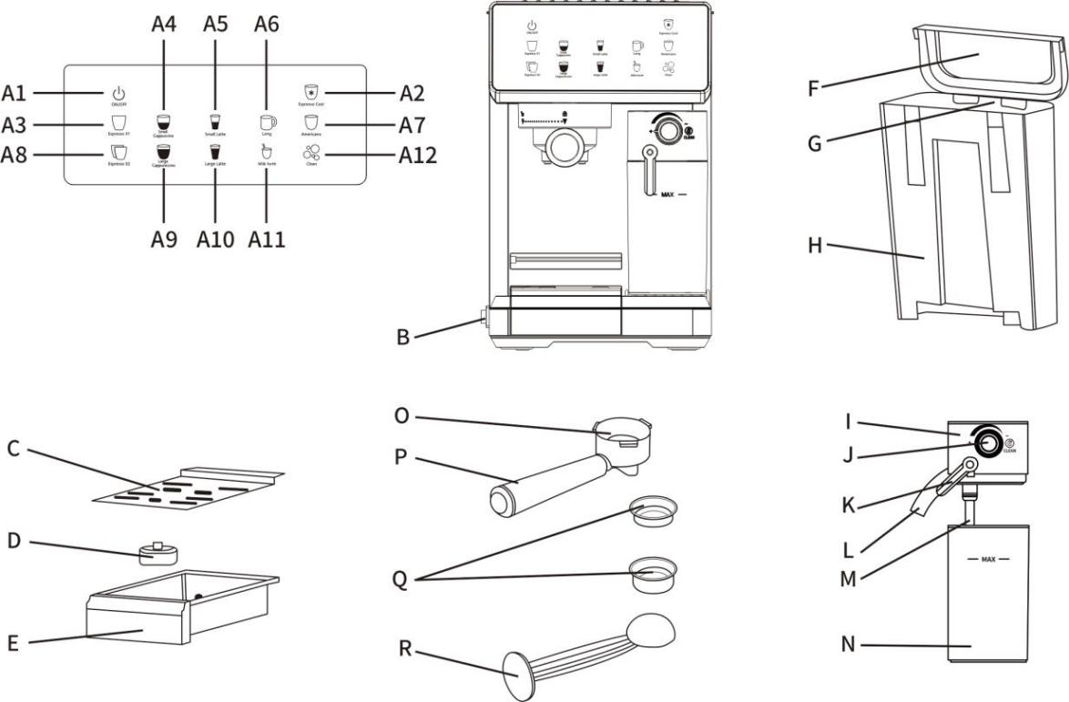

A | ON/OFF, Espresso Cool, Espresso X1, Small Cappuccino, Small Latte, Long, Americano, Espresso X2,  Large Cappuniccino, Large Latte, Milk forth, Clean
A1 | ON/OFF | A2 | Espresso Cool
A3 | Espresso X1 | A4 | Small Cappuccino
A5 | Small Latte | A6 | Long
A7 | Americano | A8 | Espresso X2
A9 | Large Cappuniccino | A10 | Large Latte
A11 | Milk forth | A12 | Clean
B | On / Off Switch “I/O” | C | Removable Drip Grid
D | Drip Tray Overflow Floater | E | Removable Drip Tray
F | Water Reservoir Lid | G | Water Reservoir Handle
H | Water Reservoir | I | Milk Reservoir Lid
J | Milk Froth Level Control Knob | K | Milk Frothing Tube Guide Lever
L | Frothed Milk Dispensing Tube | M | Milk Hose
N | Removable Milk Reservoir | O | Portafilter (Metal funnel)
P | Portafilter (Metal funnel) Handle | Q | Coffee Filter (Single shot and double shot)
R | Measuring Scoop / Tamper
INTRODUCTION
This unique appliance has been designed to help you prepare delicious espresso, cappuccino and latte quickly, conveniently and automatically with the touch of a button.

ESPRESSO
A unique method of coffee brewing in which hot water is forced through finely ground coffee. Popular in Europe, it is a far richer and more full-bodied brew than regular drip coffee. Because of its richness, espresso is usually served in 45 to 90 ml portions, in demitasse cups.
CAPPUCCINO
A drink made with about 1/3 espresso, 1/3 steamed milk, and 1/3 frothed milk foam.
LATTE
A drink made with about 1/4 espresso and 3/4 steamed milk and frothed milk foam.

Please read all of the instructions, cautions, notes and warnings included in this instruction manual carefully before you begin to use this appliance. When this unit is used, some parts and accessories get hot and need to cool down. Proper care and maintenance will ensure the long life of the coffee maker and its trouble-free operation. Save these instructions and refer to them often for cleaning and care tips.
The coffee maker can be used with ground coffee as, making it exceptionally practical and versatile to prepare single shots of espresso, cappuccino and latte.

BEFORE THE FIRST USE OF THIS PRODUCT
CLEANING THE UNIT PRIOR TO FIRST USE
Before the first use, clean the product to achieve the best operation state. Please refer to the "product introduction" section to understand this product and recognize all the parts.
- Please make sure the unit is off “O” by pressing the on/off “I/O” switch located on the left side of the unit. Make sure it is unplugged from the electrical outlet.
2. Remove stickers and labels from the unit.
3. First remove and then wash the water reservoir, the milk reservoir, the portafilter, the two filters and measuring scoop/tamper in a mixture of mild detergent and water. Rinse each thoroughly and place them back into the unit.
4. Refer to the instructions on “PLACING THE PORTAFILTER” section before placing or removing the portafilter and any filter from the unit.
5. To clean the inside of the appliance, follow the steps listed on the “PREPARING CAPPUCCINO” section using water in both reservoirs and no ground coffee in the filter. Do not immerse the main body of the appliance or power cord and plug in water or attempt to reach any of its internal parts.
IMPORTANT - PRIME THE UNIT
To prime unit, run the steam cycle by following the steps below
If the product is to be in its best condition, follow the following steps to run the steam milk function for 90 seconds.
1. Purified water in the water reservoir with the level should be between the "MIN" and the "MAX" level.
2. Milk in the milk reservior with the level should not above the "MAX" level. Place milk reservoir back onto unit, lifting up and simultaneously sliding milk reservoir in, holding reservoir by the lid. You should feel the milk reservoir lock in place.
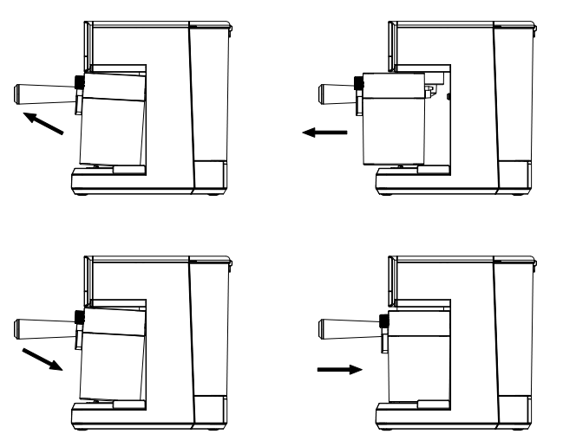
3. Select one of the filters and place it on the portafilter. Put the portafilter in the product to ensure that it is properly locked and place a cup under it. In addition, ensure that the end of the milk foam distribution pipe points to the interior of the cup.
4. Plug the appliance into the appropriate outlet.
5. Turn the power switch on “I”.
6. The lights on the six buttons of the control panel will start to shine. Once the lights are illuminated on, now the product has entered the best operation state, you can use it anytime.
Warning: If the milk reservior can not be detached in correct position, the cappuccino buttons and latte buttons will not be illuminated.

CHOOSE THE RIGHT CUP
Before making a drink, make sure that the right size cup is selected according to the following table:
BEVERAGE TYPES (AUTO MODE) |  | SUGGESTED CUP
Espresso |     Single Double | 50 ml 100 ml
Cappuccino |     Small Large | 150 ml 300 ml
Latte |     Small Large | 200 ml 350 ml

Note: the upper surface capacity is for selection only, not for the amount of coffee consumed. The total amount of the beverage can vary depending on the type of milk and level of froth used.

CHOOSE THE RIGHT COFFEE
THE COFFEE
The coffee should be freshly ground and dark roasted. You may want to try a French or Italian roast ground for espresso. Pre-ground coffee will only retain its flavour for 7 to 8 days, provided it is stored in an airtight container and in a cool, dark area. Do not store in a refrigerator or freezer. Whole beans are recommended to be ground just before use. The aroma of coffee beans stored in an airtight container will preserve flavour for up to 4 weeks.
THE GRIND
This is a vital step in the espresso making process if you are grinding your own coffee. It may require practice. The coffee must be of a fine grind.
• The correct grind should look like table salt.
• If the grind is too fine, the water will not flow through the coffee even under high pressure. These grinds look like powder and feel like salt when rubbed between fingers.
• If the grind is too coarse, the water flows through the coffee too fast, preventing a full-flavored extraction. Be sure to use a quality grinder for uniform consistency.

OPERATING INSTRUCTIONS
FILLING THE WATER RESERVOIR
a. Fill the water reservoir with water. You may use either a pitcher to fill it up or remove it from the unit and then fill it up under the tap. Fill the reservoir with the desired amount of water below the “MAX” level on the reservoir. Never use warm or hot water to fill the water reservoir.
b. Close the water reservoir lid. If you removed it from the unit to fill up with water, please make sure to place it back tightly in its place.
FILLING THE MILK RESERVOIR
If you plan to prepare a cappuccino or latte, remove the milk reservoir from the unit by lifting up the milk reservoir, simultaneously sliding milk reservoir out. Then, pour the desired quantity of cold milk you estimate you will need, making sure it is below the “MAX” level on the reservoir. Once finished, slide the milk reservoir back onto the unit ensuring it fits tightly. You should feel the milk reservoir lock in place.
NOTE: You can use any type of milk you prefer, whole milk or semi-skimmed milk.
CHOOSING THE PORTAFILTER
Your unit includes one portafilter for use with ground coffee.
CHOOSING THE FILTER
Select the filter to be used as follows:
a. FOR A SINGLE SHOT–use the filter for a single shot of espresso if using ground coffee.
b. FOR A DOUBLE SHOT OR TWO SINGLE SHOTS–use the filter for a double shot of espresso. By placing two small espresso cups underneath the portafilter, you may prepare two single shots of espresso at once.
PLACING THE FILTER ON THE PORTAFILTER
1. Insert the filter into the portafilter, making sure to align the filter dimple to the portafilter notch.
2. Turn the filter to the left or right to lock it in place.
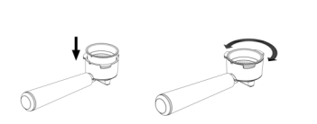
NOTE: To remove the filter for cleaning, turn the filter to the left or right to align the filter dimple to the portafilter notch and proceed to remove.
WARNING: Make sure the filter has cooled down before attempting to remove it from the portafilter.
FILLING WITH COFFEE
Place selected filter in portafilter as follows:
FOR GROUND COFFEE:
a. Fill the filter with fresh, fine ground espresso coffee about 2 mm from the rim (DO NOT overfill).
b. Using the tamping part of the scoop, push the coffee grounds downwards as far as the tamper will go to get your espresso grounds compact and even.
c. Clean any excess coffee from the rim to ensure proper fit under brew head.

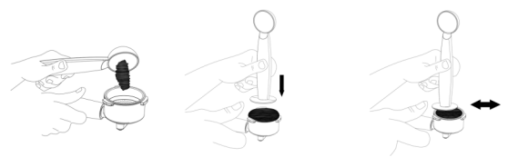
PLACING THE PORTAFILTER
a. Position portafilter underneath the brew head.
b. Position handle so that the handle lines up with the open lock icon on the unit and fits into the groove.
c. Then, slowly turn it to the right until the handle is aligned with the closed lock symbol on the unit.
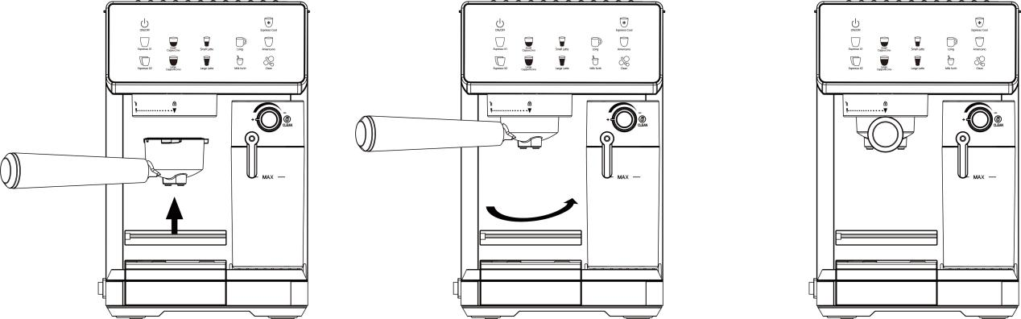

PLACING THE COFFEE CUP(S)
Removable drip grid on top of the removable drip tray if you are using a larger cup to brew cappuccino or latte.
CAUTION: When brewing cappuccino or latte, please make sure to adjust the frothing tube lever in order to position the frothed milk dispensing tube to point inside the cup that is being used.
TURNING THE UNIT ON
a. Make sure unit is plugged into the appropriate electrical outlet.
b. Turn unit on “I” using the on/off “I/O” switch located on the left side on the unit.
The control panel lights will start blinking during the heating process and until the water and milk (if preparing cappuccino or latte) reach the perfect temperature. Once these lights become solid, the unit is ready to use.
Warning: If the milk reservior can not be detached in correct position, the cappuccino buttons and latte buttons will not be illuminated.

SELECT THE FUNCTION
PREPARING ESPRESSO
a. Press the Automatic Espresso Button once to brew a single shot. The indicator light for a single shot of espresso will turn on. It will start blinking, indicating that a single shot of espresso is brewing.
b. Press the Automatic Espresso Button twice to brew a double shot or two single shots of espresso. The indicator light for a double shot of espresso will turn on. It will start blinking, indicating that a double shot of espresso is brewing.
For both Automatic Espresso functions, the unit will start brewing the espresso according to your selection. The unit will stop automatically after the brewing process and the light will become solid, indicating that the cycle has been completed. Your delicious espresso is ready to be enjoyed!
NOTE: If you would like to brew less coffee than the preset serving, press the function button at any time during the brewing process to stop when the desired amount of coffee is reached. Or you can operate the Manual Espresso Button.
c. Press the Manual Espresso Button to customize the brewing to your preference or the desired amount. For safety, unit will automatically stop after brewing MAX time.
Prior to preparing your cappuccino, adjust the level of frothed milk according to your preference by turning the Froth Control Knob to the left for more foam (cappuccino) and to the right for less foam (latte).
NOTE: The level of foam can also be adjusted during the brewing cycle.
PREPARING CAPPUCCINO
a. Press the Auto Cappuccino Button once to brew a small cup of cappuccino. The indicator light “1” for small cup of cappuccino will turn on. It will start blinking, indicating that a small cup of cappuccino is brewing.
b. Press the Auto Cappuccino Button twice to brew a large cup of cappuccino. The indicator light “2” for large cup cappuccino will turn on. It will start blinking, indicating that a large cup of cappuccino is brewing.
The unit will start brewing cappuccino according to your selection.
The unit will stop automatically after the brewing process and the light will become solid, indicating that the cycle has been completed. Your delicious cappuccino is now ready to be enjoyed!
PREPARING LATTE
a. Press the Auto Latte Button once to brew a small cup of latte. The indicator light “1” for small cup of latte will turn on. It will start blinking, indicating that a small cup of latte is brewing.
b. Press the Auto Latte Button twice to brew a large cup of latte. The indicator light “2” for large cup of latte will turn on. It will start blinking, indicating that a large cup of latte is brewing.
The unit will start brewing latte according to your selection.
The unit will stop automatically after the brewing process and the light will become solid, indicating that the cycle has been completed. Your delicious latte is now ready to be enjoyed!
Note: Press the Manual Froth Button to customize the frothing to your preference or the desired amount of foamed milk. For safety, unit will automatically stop after frothing MAX time.

AFTER PREPARING YOUR BEVERAGES WITH MILK
Once you are done preparing your beverage with milk, you can either store the unit’s milk reservoir and the milk reservoir lid directly in the refrigerator (ready to be used for the next time in short) or dispose of the leftover milk.

CLEANING THE MACHINE
CLEANING THE MILK RESERVOIR AND FROTHING TUBE
Although you can store the milk reservoir with leftover milk in the refrigerator, it is important to clean the reservoir and frothing tube regularly to avoid clogging and residue build-up. In order to clean the milk reservoir, please follow the instructions listed below:
- Remove the milk reservoir from the unit by lifting up the milk reservoir and simultaneously sliding the milk reservoir out.
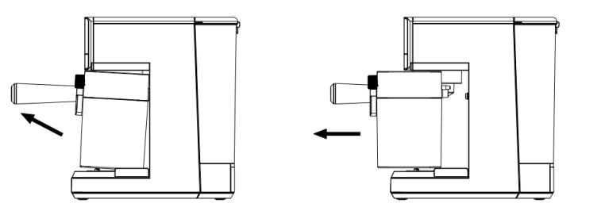

- Remove the lid of the reservoir. Dispose of the leftover milk.
- Fill milk reservoir with purified water, not above the MAX fill mark. Place milk reservoir back onto unit, lifting up and simultaneously sliding milk reservoir in, holding reservoir by the lid. You should feel the milk reservoir lock in place.

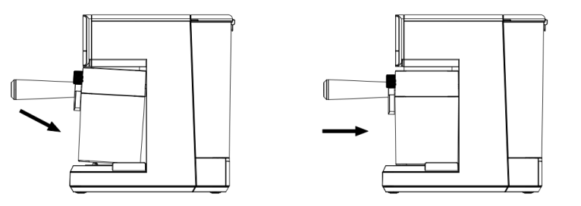

Warning: If the milk reservior can not be detached in correct position, the cappuccino buttons and latte buttons will not be illuminated.
- Place a large empty cup under the froth dispensing tube.
5. Press the CAPPUCCINO button or LATTE button, the unit will start releasing hot water through the froth dispensing tube. Let the cleaning cycle run until you no longer see any milk coming out of the tube, or repeat some cycles.
6. Turn the Froth Control Knob to the clean position then press the CLEAN button. The unit will start releasing hot steam through the froth dispensing tube. Let the cleaning cycle run, repeat some cycles.
Note: Make sure purified water in the water reservoir with the level should be between the "MIN" and the "MAX" level.
7. Repeat some cycles for above steps 3 - 6.
8. Dispose of any water left in water reservior and milk reservior, then rinse and wash the water reservior and milk reservior thoroughly with warm soapy water. Make sure to rinse and dry them well. Do not use abrasive cleaners and scouring pads, as they will scratch the finish.
NOTE: Do not place the milk reservoir lid in the dishwasher. The milk reservoir is dishwasher safe.
CLEANING THE BREW HEAD, THE PORTAFILTER AND FILTERS
1. Press the on/off “I/O” switch located on the left side of the unit to the off position “O” and unplug the power cord from the electrical outlet.
2. Some of the metal parts may still be hot. Do not touch them with your hands until they have cooled.
3. Remove the portafilter and discard the coffee grounds. Wash both the portafilter and filter thoroughly with warm soapy water. Make sure to rinse and dry them well.
NOTE: Do not wash the portafilters and filters in the dishwasher.
4. Wipe the lower part of the brew head in the unit with a damp cloth or paper towel to remove any coffee grounds that might have been left.
5. Place the portafilter (without any filter) back in the brew head in the unit and lock it in place.
6. Place a large empty cup under the portafilter.
7. Plug the power cord into the electrical outlet. Press the on/off “I/O” switch to the on position “I”. Press the Espresso button once and let the unit brew with water until it stops automatically.
CLEANING THE WATER RESERVOIR
1. Dispose of the remaining water by removing the water reservoir and turning it upside down over the sink. It is recommended to empty the water reservoir between uses.
2. Wash the water reservoir and its lid thoroughly with warm soapy water. Make sure to rinse and dry them well.
NOTE: Do not wash the water reservoir or its lid in the dishwasher.
CAUTION: Do not immerse main body of the appliance or power cord and plug in water or any other liquid.
CLEANING THE UNIT
1. Wipe housing with a soft wet cloth. Do not use abrasive cleaners or scouring pads, as they will scratch the finish.
2. Do not store any of the portafilters in the brew head. This can adversely affect the seal between the brew head and the portafilter while brewing espresso.

DESCALING
Build-up of mineral deposits in the unit will affect the operation of the appliance. Your appliance must be descaling when you begin to notice an increase in the time required to brew espresso, or when there is excessive steaming. Also, you may notice a build-up of white deposits on the surface of the brew head. The frequency of cleaning depends upon the hardness of the water used. The following table gives the suggested cleaning intervals.
Type of Water | Cleaning Frequency
Soft Water (Filtered Water) | Around every 80 ~ 100 Brew Cycles
Hard Water (Tap Water) | Around every 40 ~ 50 Brew Cycles
TO DESCALE WATER RESERVOIR:
1. Fill the water reservoir with fresh, undiluted white household vinegar.
2. Allow appliance to sit overnight with the vinegar solution in the water reservoir.
3. Discard vinegar by removing the reservoir and turning it upside down over the sink.
4. Rinse the water reservoir thoroughly with tap water by filling the reservoir half full with water and then pouring the water back out into the sink, repeating this step twice.
TO DESCALE INTERNAL PARTS:
- Make sure you descale the inside of the water reservoir first by following the descale steps above.
- Fill the water reservoir and milk reservoir with fresh, undiluted white household vinegar.
- Make sure to switch the on/off button to the off “O” position and the power cord is disconnected from the electrical outlet. Fill the reservoir with undiluted white household vinegar.
- Insert the portafilter (with filter and no coffee) and place a large empty cup on top of the drip tray and under the portafilter.
- Plug the power cord into the electrical outlet.
- Place a large empty cup under the froth dispensing tube.
- Press the on/off button to switch the unit on “I”, once the control panel lights (Espresso, Cappuccino and Latte) turn solid, press the CAPPUCCINO button or LATTE button. The unit will start releasing hot water through the froth dispensing tube and the portafilter. Let the cleaning cycle run, repeat some cycles.
- Turn the Froth Control Knob to the clean position then press the Clean Button. The unit will start releasing hot steam through the froth dispensing tube. Let the cleaning cycle run, repeat some cycles.
Note: Make sure purified water in the water reservoir with the level should be between the "MIN" and the "MAX" level.
- Repeat some cycles for above steps 2 - 8.
- Dispose of any water left in water reservior and milk reservior, then rinse and wash the water reservior and milk reservior thoroughly with warm soapy water. Make sure to rinse and dry them well. Do not use abrasive cleaners and scouring pads, as they will scratch the finish.
NOTE: Do not place the milk reservoir lid in the dishwasher. The milk reservoir is dishwasher safe.

AUTOMATICALLY POWER-OFF FUNCTION
After pressing power button, if there is no any operation within 25 minutes, the unit will power off automatically.

SYMPTOM, CAUSES AND SOLUTIONS
Symptom | Causes | Solutions
Coffee does not  come out. | •No water in reservoir.  •Coffee grind is too fine.  •Too much coffee in the  filter.  •Appliance was not turned  on or plugged in.  •Coffee has been tamped/  compressed too much. | •Add water.  •Grind medium ground coffee.  •Fill filter with less coffee.  •Plug unit into electrical  outlet and turn it on.  •Refill filter basket with coffee  and TAMP GENTLY.
Coffee comes out  around the edge of  the portafilter. | •Portafilter not rotated to full lock position.  •Coffee grounds around the filter basket rim.  •Too much coffee in the filter. | •Rotate filter holder to full  lock position.  •Wipe off rim.  •Fill with less coffee.
Milk is not foamy  after frothing or it is  not coming out of  the frothing tube. | •Ran out of steam.  •Milk is not cold enough.  •Frothing tube is blocked. | •Ensure there is enough  water in the water reservoir.  •Chill milk and frothing  pitcher prior to making  Cappuccino or latte.  •Follow the instructions to  clean the milk reservoir &  frothing tube.
Coffee comes out  too quickly. | •Ground coffee is too coarse.  •Not enough coffee in filter. | •Use a finer grind.  •Fill filter with more coffee.
Coffee is too weak. | •Using single filter for double shot of espresso.  •Ground coffee is too coarse. | •Use double filter for double  shot of espresso.  •Use a finer grind.
Do not take apart the appliance by yourself if the cause of failure is not found, contact the qualified servicing center.


ENVIRONMENT FRIENDLY DISPOSAL
You can help protect the environment!
Please remember to respect the local regulations:
Hand in the non-working electrical equipment to
an appropriate waste disposal center.

