INSTRUCTION MANUAL

- SAFETY WARNINGS
Danger! Failure to observe the warning may result in life threatening injury by electric shock.
This is an electrical appliance and may cause electrical shocks. You should therefore follow these safety warnings:
- Never touch the appliance with damp hands or feet.
- Never touch the plug with damp hands.
- Make sure the socket used is freely accessible at all times, enabling the appliance to be unplugged when necessary.
- Unplug directly from the plug only. Never pull the cord as you could damage it.
- To disconnect the appliance completely you must unplug it from the mains socket.
- If the appliance is faulty, do not attempt to repair. Turn it off, unplug from the mains socket and contact Customer Services.
- Before cleaning the appliance, turn it off, unplug from the mains socket and allow to cool.
 Important: Failure to observe the warning could result in injury or damage to the appliance.
Keep all packaging (plastic bags, polystyrene foam) away from children.
 Danger of burns! Failure to observe the warning could result in scalds or burns.
This appliance produces hot water and steam may form while it is in operation.
Avoid contact with splashes of water or hot steam.

Designated use and restrictions
This appliance is designed and made to prepare coffee or hot water and to heat milk using steam.
Use drinking water only to fill the tank as described in the Instruction for Use.
Never use the hot water/steam spout with beverages other than milk.
Any other use is considered improper and thus dangerous. The manufacturer is not liable for damage deriving from improper use of the appliance.

Instruction for Use
Read this Instruction for Use carefully before using the appliance. Failure to follow this Instruction for Use may result in burns or damage to the appliance.
The manufacturer is not liable for damage deriving from failure to respect this Instruction for Use.
Please note:
Keep this Instruction for Use. If the appliance is passed to other persons, they must also be provided with this Instruction for Use.

Checking the appliance
After removing the packaging, make sure the product is complete and undamaged and that all accessories are present. Do not use the appliance if it is visibly damaged.

- DISPOSING OF THE APPLIANCE
The appliance must not be disposed of with household waste, but taken to an authorised waste separation and recycling centre.

TECHNICAL DATA
Mains voltage: 120V~60Hz
Absorbed power:1300W
Pressure: 20 Bar
Water tank capacity : 0.9L
Size LxHxD: 293mm*125mm*295mm
NET Weight : 3.2kg

None of the components or accessories is dishwasher safe.

- DESCRIPTION
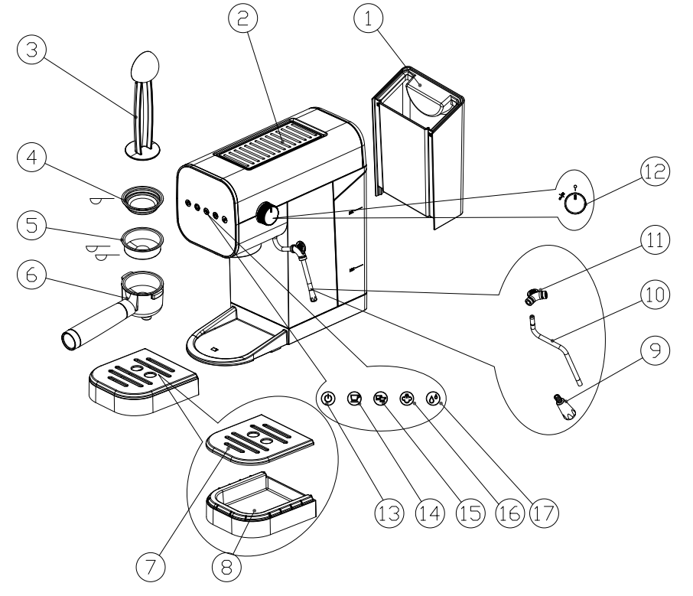

Description of the appliance
9.STEAM NOZZLE
10.STEAM WAND
11.ANTI-SCALD TUBE
12.STEAM/WATER CONTROL KNOB
13.ON/OFF BUTTON
14.1CUP BUTTON
15. 2CUP BUTTON
16.STEAM BUTTON
17.HOT WATER BUTTON

1.REMOVABLE WATER TANK
2.HOLDING PLATE FOR WARMING CUPS
3.MEASURING SPOON WITH INTEGRATED TAMPER
4. 1 CUP FILTER
5. 2 CUP FILTER
6.HANDLER/FILTER HOLDER
7/8.REMOVABLE DRIP TRAY AND COVER

- INSTALLING THE APPLIANCE

Important! When you install the appliance, you should respect the following safety warnings:
- Water penetrating the coffee maker could cause damage. Do not place the
appliance near taps or sinks.
- The appliance could be damaged if the water it contains freezes.Do not install the
appliance in a room where the temperature could drop below freezing point.
- Arrange the cord in such a way that it cannot be damaged by sharp edges or
contact with hot surfaces (e.g. electric hot plates) .
- The appliance gives off heat. After positioning the appliance on the worktop,
leave a space of at least 3 cm between the surfaces of the appliance and the side and rear walls and at least 15cm above the machine.
- Clean all the removable parts with tap water.

5.1 Connecting the appliance

Danger!
Check that the mains power supply voltage corresponds to that indicated on the rating plate on the bottom of the appliance. Connect the appliance to an efficiently earthed and correctly installed socket.If the power socket does not match the plug on the appliance, have the socket replaced with a suitable type by a qualified professional.

- FILLING THE WATER TANK

Please note:
Before first use, wash all the accessories and water tank with warm water.
- Extract the tank by pulling it back .
- Fill the tank with fresh clean water, taking care not to exceed the MAX level . Put the tank back in the appliance.
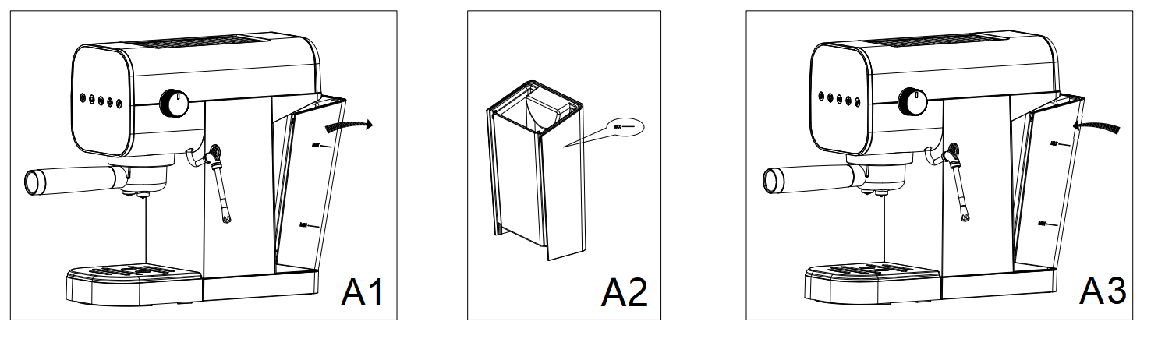

Important:
Never operate the appliance without water in the tank or without the tank.
- Please fill with soft drinking water or filtered water, Hard water will cause to shorten the service life of the machine. Do not add any chemical cleaners into the tank.

 Please note:
- It is normal for there to be water in the space under the tank. This should therefore be dried regularly with a clean sponge.

- FIRST USE

At first use, rinse the internal circuit as follows:
- Fill the water tank according to chapter 6 and attach the filter holder in the machine.
- Plug in,all lights flash 3 times and all lights off for standby mode.
- Press the ON/OFF button,the1-CUP and 2-CUP lights flash to indicate the appliance is heating up.
- Press the STEAM button and turn on the steam knob to release the residual air.Keep this operation last for 30 seconds until the steam come out.Follow this operation when the machine is the first time use or long time no use.

Important:The residual air inside may cause the machine not working properly!
- Turn off the STEAM button and press the ON/OFF button to turn off the machine for next step.
- Attach the filter holder to the appliance.
- Press the ON/OFF button,place a container with a minimum capacity of 500 ml under the boiler outlet and press the 2-CUP button when the lights are steady. Repeat this operation 5 times.
- The machine will be automatic power off if without any operation after 20 minutes.You can press the ON/OFF button to start again.
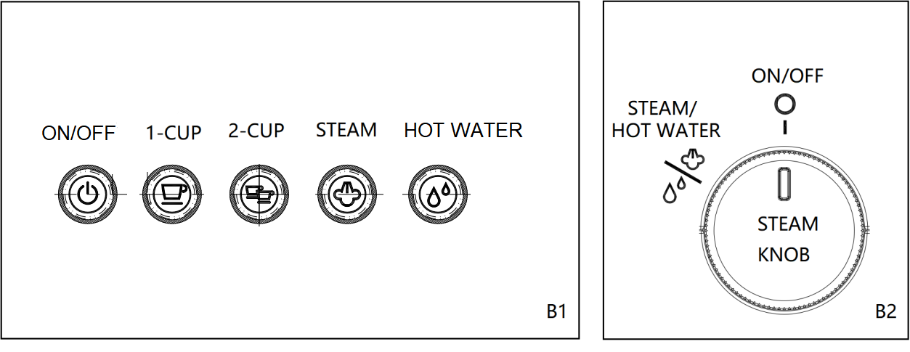

- HOW TO MAKE ESPRESSO COFFEE
8.1 How to make a hotter coffee
For making espresso coffee, you should:
- You are recommended to warm the cups before making coffee by rinsing them with a little hot water.
- Attach the filter holder to the appliance with the filter in place but without adding ground coffee. Using the same cup as will later be used to make the coffee, press the one cup button and deliver hot water into the cup to heat it.
- Rest the cups you will be using on the cup warmer which becomes hot during operation.

8.2 How to prepare espresso coffee using pre-ground coffee
- Place the ground coffee filter in the filter holder.
- To make one coffee, use the filter with the ‘1-cup’ symbol on the bottom.To make two coffees,use the filter with the ‘2-cup’ symbol on the bottom.
- To make just one coffee, place one level measure of pre-ground coffee in the filter. To make two coffees, place two loosely filled measures of pre-ground coffee in the filter. Fill the filter a little at a time to prevent the pre-ground coffee from overflowing.
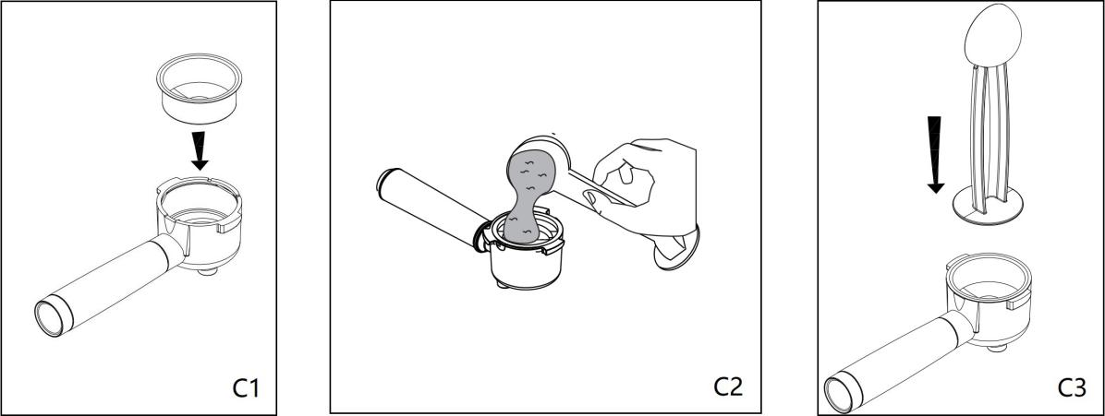

Important: For correct operation, before filling with pre-ground coffee, make sure there are no coffee residues left in the filter from the last time you made coffee.
- Distribute the pre-ground coffee evenly and press lightly with the presser.
- Correct pressing of the pre-ground coffee is essential to obtain a good espresso.If you press too firmly, the coffee will be delivered slowly and will be strong. If you press too lightly, the coffee will be delivered quickly and will be weak.
- Remove any excess coffee from the rim of the filter holder and attach the filter holder to the appliance. To attach correctly, align the filter holder handle with the UNLOCK symbol,attach the filter holder and rotate the handle towards the right until aligned with the LOCK symbol.
- Place the cup or cups under the filter holder spouts.
- Make sure the lights corresponding to the coffee buttons are on, then press the 1-CUP or 2-CUP coffee button. The appliance proceeds to make the coffee and delivery is interrupted automatically.
- To remove the filter holder, turn the handle from right (LOCK) to left (UNLOCK).
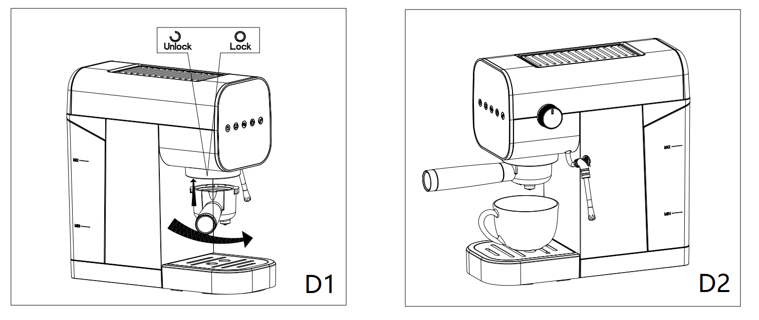

Danger of burns!
To avoid splashes, never remove the filter holder while the appliance is delivering coffee. Always wait for a few seconds after delivery.

8.3 Programming the quantities of coffee in the cup
The appliance is set by default to automatically deliver standard quantities. To change these quantities, proceed as follows:
- Prepare the espresso coffee as described in section 8.2
- Place the cup or cups under the filter holder spouts.
- Press and hold the button you want to programme 1-CUP or 2-CUP.The first 3 seconds are for activating this function,then coffee maker starts delivering coffee.
- Once the required quantity of coffee has been delivered into the cup, release the button. Delivery stops and the beep a sound to indicate that the quantity has been saved correctly.
- When the two coffee lights come on steadily, the appliance is ready for use.

Please note:For 1-CUP,the shortest delivery time is 12 seconds,the longest delivery time is 22 seconds.For 2-CUP ,the shortest delivery time is 20 seconds,the longest delivery time is 51 seconds.The time is not including the first 3 seconds.

8.4 Resetting the quantity of coffee
If you want to cancel the quantity of coffee , please proceed as follows :
- Connect the machine to power supply , but do not press ON/OFF button .
- Press 1-CUP and 2-CUP simultaneously (do not release) and last for 3 seconds,then the machine with a beep sound and all lights flash 3 times,indicating that the quantity of coffee has been reset.

- HOW TO MAKE CAPPUCCINO
- Prepare the espresso coffees as described in the previous sections, using
sufficiently large cups.
- Press the STEAM button and the indicator light on.
- In the meantime, fill a recipient with about 100 grams of milk for each cappuccino
to be prepared.For a denser more even froth, you must use whole milk at refrigerator temperature (about 5°C). In choosing the size of the recipient, bear in mind that the milk doubles or triples in volume.
- Put an empty container under the cappuccino maker and open the dial for a few
seconds to eliminate any air left in the circuit. Close the dial again.
- Place the recipient containing the milk under the cappuccino maker.
- Immerse the cappuccino maker in the milk container. Never immerse the black
ring . Turn the dial to the STEAM position. Steam is delivered from the cappuccino maker, giving the milk a creamy frothy appearance . To obtain a creamier froth, immerse the cappuccino maker in the milk and rotate the container with slow upward movements.
- When the required temperature (the ideal is 60°C) and froth density is reached,
interrupt steam delivery by turning the steam dial to OFF position.
- Pour the frothed milk into the cups containing the espresso coffee prepared
previously, the cappuccino is ready. Sweeten to taste and if desired, sprinkle the froth with a little cocoa powder.
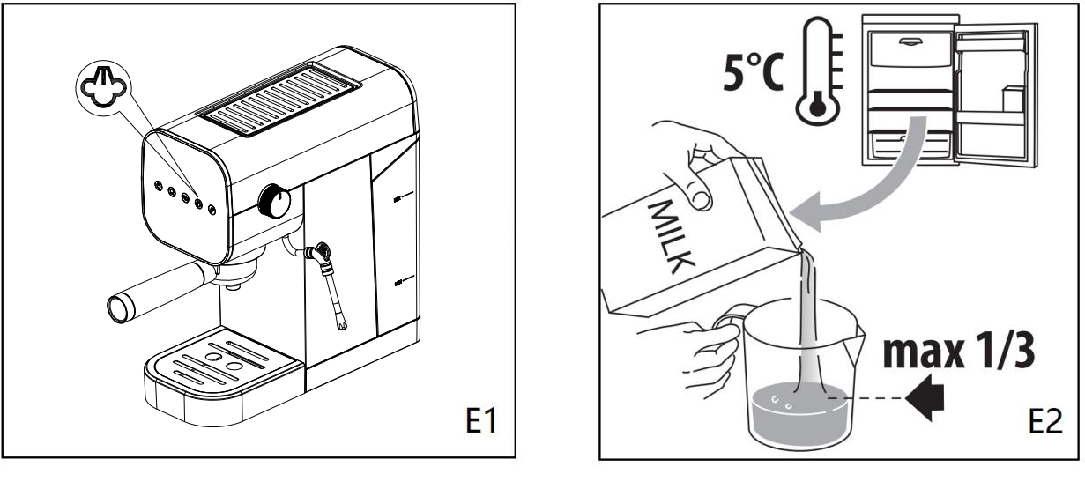

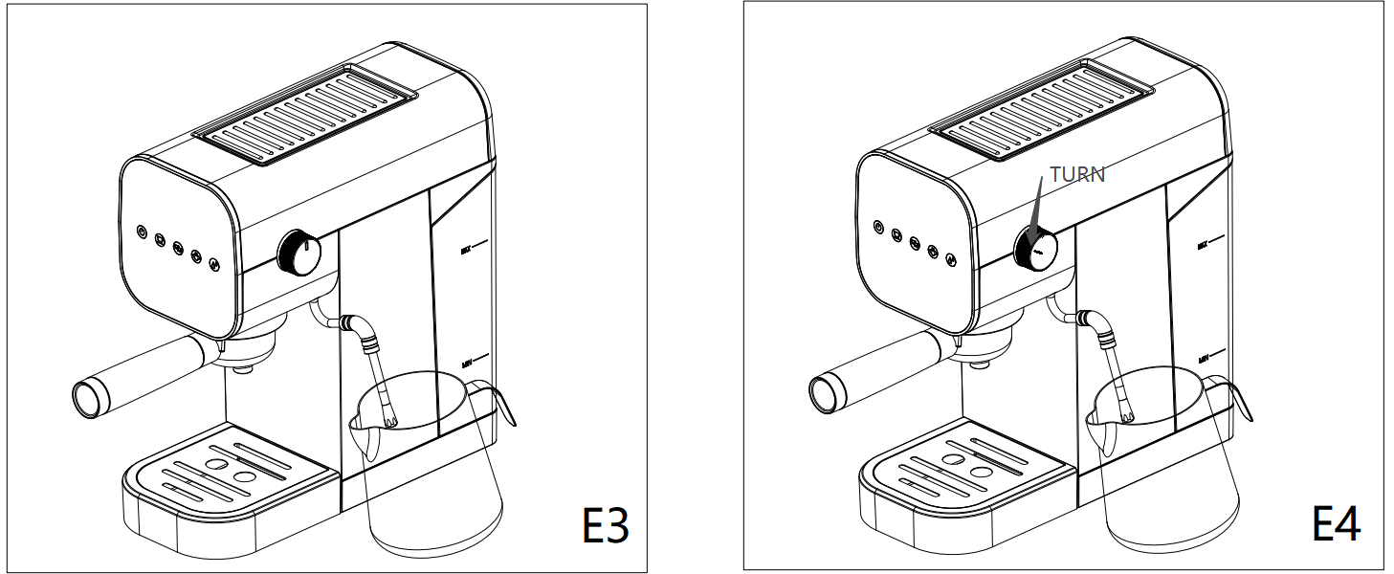

Please note:
- To prepare more than one cappuccino, first make all the coffees then at the end
prepare the frothed milk for all the cappuccinos;
- To make coffee again immediately after frothing milk, the boiler must first be cooled or the coffee will be burnt, so we suggest to press 1-CUP or 2-CUP button and release few high temperature water before make another cup of coffee.
- Be careful about the splashing hot water and steam released from the cappuccino maker pipe.
- When the steam button light up,you can not choose the 1-CUP or 2-CUP function,press the steam button again to cancel the steam mode.

Do not deliver steam for more than 60 seconds.

- HOW TO MAKE HOT WATER
1.Turn the appliance on by pressing the ON/OFF button.
2.Put a cup under the water outlet(steam wand).
3.Press the ‘HOT WATER’ button and open the steam knob to dispense water .
4.You can stop the water by pressing the ‘HOT WATER’ button.
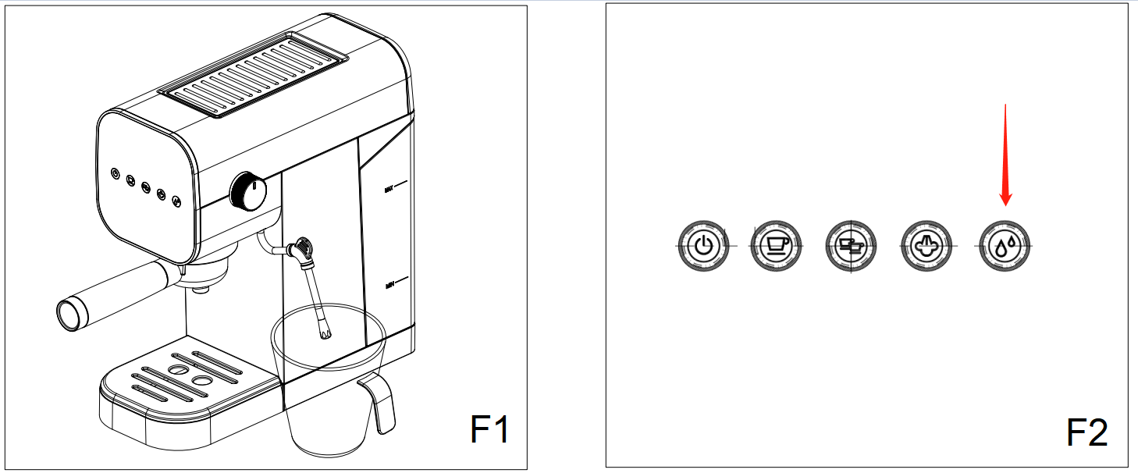

Please note:
- Note:Water will be hot, if using a metal Jug, the Jug will get hot. Risk of scalding and burns.
- When the WATER button light up,you can not choose the 1-CUP or 2-CUP function,press the WATER button again to cancel the WATER mode.
- Turn the ON/OFF button to the “OFF”position and unplug the appliance when not in use.

CLEANING

Important!
- Do not use solvents, abrasive detergents or alcohol to clean the coffee machine.
- Do not use metal objects to remove encrustations or coffee deposits as they could scratch metal or plastic surfaces.
- If the appliance is not used for more than one week, before using it again, we strongly recommend you perform a rinse cycle as described in section ”7. first use”.

Danger!
- While cleaning, never immerse the coffee maker in water. It is an electrical appliance.

11.1 Descale

Important: In order to ensure the pure taste of coffee, please descale the coffee machine after 2-3 months of use.
- Ensure that the descaling product is suitable for coffee machines.Or use the citric acid (100 water:3 citric acid) instead of the descaling product.
- Fill the water tank with the descaling solution.
- Place a large container on the drip tray. Operate as if making coffee and steaming until the tank is empty.
- Rinse the water tank and fill with water.
- Operate as if making coffee and flush water through the machine.This will remove any traces of the descaling solution.
- Store the cleaned coffee machine unplugged with no coffee in the filter and with the water tank empty.

11.2 Cleaning the drip tray

Important! Please pay attention to the amount of water in the drip tray . Before water overflows from the cup tray , the drip tray must be emptied and cleaned otherwise the water may overflow the edge and damage the appliance, the surface it rests on or the surrounding area. We suggest to clean it every time when you using . When clean the drip tray , please proceed as follow :
- Remove the drip tray and cup tray.
- Separate the cup tray and drip tray , clean them with a soft damp cloth, then reassemble them.
- Dry and put it back in the machine.

11.3 Cleaning the coffee filters
Clean the coffee filters regularly:
- Rinse the filters under running water;
- Make sure the holes are not blocked. If necessary, clean with a pin.

11.4 Other cleaning operations
- Do not use solvents or abrasive detergents to clean the coffee maker. Use a soft damp cloth only.
- Clean the filter holder cup.

11.5 Cleaning the water tank
Clean the water tank regularly (about once a month) with a damp cloth and a little mild washing up liquid;

11.6 Cleaning the cappuccino maker

Important:
For hygiene reasons, the cappuccino maker should always be cleaned after use. Proceed as follow:
Turn the steam dial to deliver a little steam for a few seconds. This causes the cappuccino maker to discharge any milk left inside.
- Press the ON/OFF button to turn the appliance off.
- Ensure that the Froth Nozzle is cool before cleaning. Pull the Froth Nozzle off the Steam Wand and wash under running water to remove any milk residue. Risk of burns.

Danger!
While cleaning, never immerse the coffee maker in water.
It is an electrical appliance.

- COMMON TROUBLE SHOOTING
Please read the following instructions and keep them on hand for later reference .

Problem | Cause | Solution
No espresso coffee  is delivered | Residual air inside | Open the steam knob after heating up as described in section ‘7.FIRST USE’
No espresso coffee  is delivered | No water in the tank | Fill the tank
No espresso coffee  is delivered | The holes in the filter holder are blocked | Clean the filter holder spout holes
No espresso coffee  is delivered | The filter is blocked | Clean as described in section “11.3 Cleaning the coffee filters”
No espresso coffee  is delivered | The tank has been inserted incorrectly and the valves on the bottom are not open | Press the tank down lightly to open the valves on the bottom
No espresso coffee  is delivered | Limescale in the water circuit | Descale as described in section “11.1 Descale”
The espresso coffee drips from the edges of the filter holder rather than the holes | The filter holder has been inserted incorrectly or is dirty | Attach the filter holder correctly and rotate firmly as far as it will go
 | The holes in the filter holder spouts are blocked | Clean the filter holder spout holes
 | The filter is blocked | Clean as described in section “11.3 Cleaning the coffee filters”
The filter holder cannot be attached  to the appliance | Too much coffee has been placed in the filter | Use the measure supplied and make sure you are using the correct filter for the type of preparation
The appliance will not make any coffee and the function button lights flash for a few seconds. | No water in the tank | Fill the tank with water
 | The tank has been inserted incorrectly and the valves on the bottom are not open | Press the tank down lightly to open the valves on the bottom
 | The filter is blocked | Clean as described in section “11.3 Cleaning the coffee filters”
 | Limescale in the water circuit | Descale as described in section “11.1Descale”
The coffee froth is too light (delivered from the spout too fast) | The pre-ground coffee is not pressed down firmly enough | Press the pre-ground coffee more firmly
 | There is not enough pre-ground coffee | Increase the quantity of pre-ground coffee
 | The pre-ground coffee is too coarse | Use only pre-ground coffee for espresso coffee makers
 | The wrong type of pre-ground coffee is being used | Change the type of pre-ground coffee

The coffee froth is too dark (delivered from the spout too slowly) | The pre-ground coffee is pressed down too firmly | Press the coffee down less firmly
 | There is not enough pre-ground coffee | Reduce the quantity of pre-ground coffee
 | The filter is blocked | Clean as described in section “11.3 Cleaning the coffee filters”
 | The pre-ground coffee is too fine | Use only pre-ground coffee for espresso coffee makers
 | The pre-ground coffee is too fine or damp | Use pre-ground coffee for espresso coffee makers only and make sure it is not too damp
 | Limescale in the water circuit | Descale as described in section “11.1 Descale”
No milk froth is formed when making cappuccino | Milk not cold enough | Always use milk at refrigerator temperature （5°C)
No milk froth is formed when making cappuccino | Cappuccino maker dirty | Clean as described in section “11.6 Cleaning the cappuccino maker after using”
No milk froth is formed when making cappuccino | Limescale in the water circuit | Descale as described in section “11.1 Descale”
The appliance does not function and all function button lights flash |  | Disconnect the appliance immediately and contact Customer Services

