INSTRUCTION MANUAL

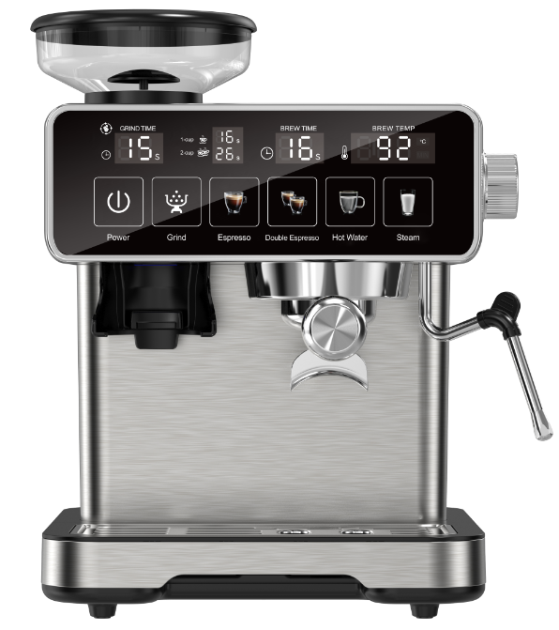

- SAFETY WARNINGS
 Danger! Failure to observe the warning may result in life threatening injury by electric shock.
This is an electrical appliance and may cause electrical shocks. You should therefore follow these safety warnings:
- Never touch the appliance with damp hands or feet.
- Never touch the plug with damp hands.
- Make sure the socket used is freely accessible at all times, enabling the appliance to be unplugged when necessary.
- Unplug directly from the plug only. Never pull the cord as you could damage it.
- To disconnect the appliance completely you must unplug it from the mains socket.
- If the appliance is faulty, do not attempt to repair. Turn it off, unplug from the mains socket and contact Customer Services.
- Before cleaning the appliance, turn it off, unplug from the mains socket and allow to cool.
 Important: Failure to observe the warning could result in injury or damage to the appliance.
Keep all packaging (plastic bags, polystyrene foam) away from children.
 Danger of burns! Failure to observe the warning could result in scalds or burns.
This appliance produces hot water and steam may form while it is in operation.
Avoid contact with splashes of water or hot steam.

Designated use and restrictions
This appliance is designed and made to prepare coffee or hot water and to heat milk using steam.
Use drinking water only to fill the tank as described in the Instruction for Use.
Never use the hot water/steam spout with beverages other than milk.
Any other use is considered improper and thus dangerous. The manufacturer is not liable for damage deriving from improper use of the appliance.

Instruction for Use
Read this Instruction for Use carefully before using the appliance. Failure to follow this Instruction for Use may result in burns or damage to the appliance.
The manufacturer is not liable for damage deriving from failure to respect this Instruction for Use.
 Please note:
Keep this Instruction for Use. If the appliance is passed to other persons, they must also be provided with this Instruction for Use.

Checking the appliance
After removing the packaging, make sure the product is complete and undamaged and that all accessories are present. Do not use the appliance if it is visibly damaged.

- DISPOSING OF THE APPLIANCE
The appliance must not be disposed of with household waste, but taken to an authorised waste separation and recycling centre.

TECHNICAL DATA
Voltage: 220-240V, 50Hz
Coffee power: 1158-1258W
Mil power: 120W
Pressure: 20 Bar
Water tank capacity : 2L
Bean-house capacity: 120g
Size L*H*D: 288mm*277mm*365mm
Accessories: Portafilter, Single shot filter, Double shot filter, Spoon, Cleaning Brush A, Cleaning Brush B, Grinding Ring

None of the components or accessories is dishwasher safe.

GETTING STARTED
4.1 Water Tank
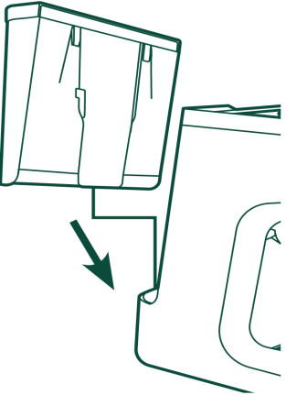
- Remove the water tank and red seal from the bottom of
the tank and fill it with water. Gently press down on the
Water Tank so it is secure in the machine before using any functions.
- Make sure the water level is between the MIN and MAX lines
in the Water Tank before use.
- Never operate the appliance without water in the tank or without
the tank.
- Please fill with soft drinking water or filtered water, Hard water will
cause to shorten the service life of the machine. Do not add any
chemical cleaners into the tank.
- It is normal for there to be water in the space under the tank. This should therefore be
dried regularly with a clean sponge.

4.2 Coffee Bean
- Espresso is sensitive to bean selection and grind size. We recommend to start with a grind
size of 4 to 8. Overly fine grounds may result in clogging and short shots. See chapter “10.Dial In Instructions” for instructions on dialing in your perfect shot.
- Remove the bean hopper from the packaging.
- Place the bean hopper into the machine by aligning the arrow with the machine. Turn the bean
hopper clockwise to lock in place. Turn the bean hopper to a grind size between 5 and 9.
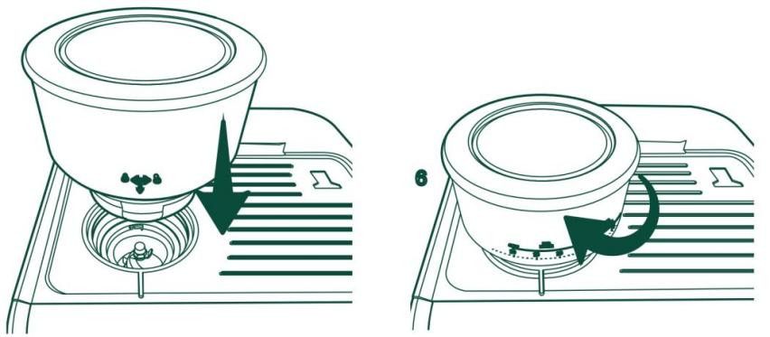
Important: The Grinder indicator will show “NO” if the hopper is removed or not locked into place. Place hopper into the machine and rotate to locked position to resolve.

NOTE: The hopper grind size setting ranges from 0-20, 0 is the finest and 20 is the coarsest.
NOTE: It is recommended to use whole coffee beans instead of pre-ground coffee. Pre-ground coffee loses its aroma and taste quickly.
NOTE: It may take several tries to get a grind size that best fits your taste.
- Follow in dial instructions on page 9 “10.Dial In Instructions”.
- Ready to Use!
- Plug in your espresso machine. The Power button will flash. Press the Power button.
- Choose your desired function and enjoy! See the section for instructions of each function.

DESCRIPTION
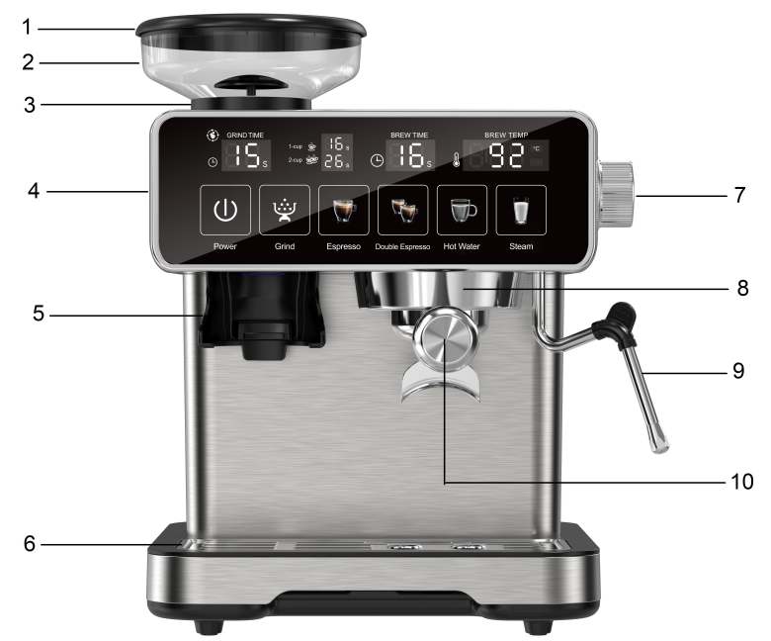
5.1 Description of the appliance
- Bean Hopper lid
- Bean Hopper
- Hopper Rotor and Burr
- LED Display
- Portafilter Cradle
- Drip tray
- Steam Knob
- Group-head
- Steam Wand
- Porta Filter

5.2 Control Panel
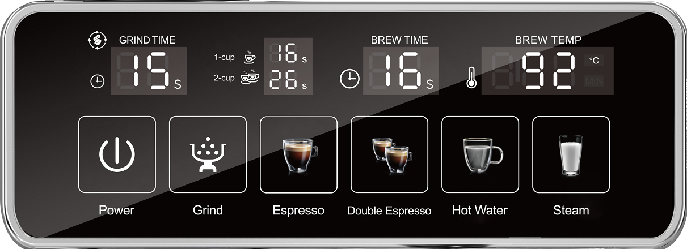

5.2.1 Buttons
- Power : Press the Power button to turn on the espresso machine.
- Grind : Press the Grind button to start grinding,press again to stop it.

NOTE: The default working time for the Grind button is 15 seconds. Once the countdown is completed, the grinding will stop automatically.
NOTE: To set Default Dispense Amount: Plug in,long press and hold Grind button for 3 seconds, then release the button, the LED display shows ‘15S’. You can press Grind button to adjust the grinding time,press 1 time to add 1 second. You can also press and hold the button to adjust. Stop pressing(stop 5 seconds) the button to save the new amount.
NOTE: For grinding, the shortest custom time is 10 seconds and the longest custom time is 30 seconds. (If the adjustment process does not stop even after reaching the maximum custom time, the time will automatically jump back to the shortest custom time and start the adjustment anew.)
NOTE: If the LED display showing “HOT”, the machine will stop grinding,let the machine rest for 5 minutes and the grinding function will return to normal.
NOTE: Coffee ground amounts and espresso volumes may vary depending on bean type and machine settings.
NOTE: Using an overly coarse grind will result in an overflowing portafilter and weaker coffee. Larger grind sizes can be used for other coffee types.
NOTE: Using an overly fine grind size may result in not enough grounds to fill the filter, as well as over pressure. Finer grind settings are included for user to adjust grind size as grinder dulls with use.
NOTE: Coffee ground amounts and espresso volumes may vary depending on bean type and machine settings.
NOTE: Using an overly coarse grind will result in an overflowing portafilter and weaker coffee. Larger grind sizes can be used for other coffee types.
NOTE: Using an overly fine grind size may result in not enough grounds to fill the filter, as well as
Over pressure. Finer grind settings are included for user to adjust grind size as grinder dulls with use.

- Espresso : Press the 1-cup button once for a single espresso. The default delivery time is 16s ,quantities of coffee is 40ml±10ml.Adjustable time range 12~22 seconds.
- Double Espresso : Press the 2-cup button once for a double espresso. The default delivery time is 26s ,quantities of coffee is 60ml±10ml.Adjustable time range 20~35 seconds.

NOTE: To set Default Dispense Amount: Plug in,long press and hold Single/Double button for 3 seconds,then release the button,the LED display shows ‘16S’/ ‘26S’. You can press Single/Double button to adjust the brew time,press 1 time to add 1 second. You can also press and hold the button to adjust. Stop pressing(stop 5 seconds) the button to save the new amount.
NOTE: For single cups, the shortest custom time is 12 seconds and the longest custom time is 22 seconds. For the dual cups, the shortest custom time is 20 seconds, and the longest custom time is 35 seconds (If the adjustment process does not stop even after reaching the maximum custom time, the time will automatically jump back to the shortest custom time and start the adjustment anew.).
NOTE: Espresso volumes are inherently small, and the range of volume adjustment is finite. If the dispense is not stopped during changing the default volume, the machine will default to the maximum setting.
NOTE: Changes to volumes may affect the flavor of the espresso.

- Hot water : is used to deliver the hot water from the steam wand.

NOTE: To set Default Dispense Amount: Plug in,long press and hold “Hot water” button for 3 seconds,then release the button,the LED display shows ‘50S’. You can press “Hot water” button to adjust the brew time,press 1 time to add 1 second. You can also press and hold the button to adjust. Stop pressing(stop 5 seconds) the button to save the new amount.
NOTE: For hot water, the shortest custom time is 20 seconds and the longest custom time is 90 seconds. (If the adjustment process does not stop even after reaching the maximum custom time, the time will automatically jump back to the shortest custom time and start the adjustment anew.).

- Steam is used to heat up liquids through the steam wand. To avoid possible burns to body parts and/or other injury from hot steam, do not touch liquids or steam wand during or after steaming. Do not remove pitcher until steaming.

NOTE: Press the steam button, the boiler will heat up to 105°C and stop,after open the steam knob the temperature will heat up again and ready to steam.

5.2.2 LED display
- LED display is showing the grinding time.
- LED display is showing the default or preset time for making coffee.
- LED display is showing the brew time.
- LED display is showing the temperature.

INSTALLING THE APPLIANCE

Important! When you install the appliance, you should respect the following safety warnings:
- Water penetrating the coffee maker could cause damage. Do not place the
appliance near taps or sinks.
- The appliance could be damaged if the water it contains freezes.Do not install the
appliance in a room where the temperature could drop below freezing point.
- Arrange the cord in such a way that it cannot be damaged by sharp edges or
contact with hot surfaces (e.g. electric hot plates) .
- The appliance gives off heat. After positioning the appliance on the worktop,
leave a space of at least 3 cm between the surfaces of the appliance and the side and rear walls and at least 15cm above the machine.
- Clean all the removable parts with tap water.

6.1 Connecting the appliance

Danger!
Check that the mains power supply voltage corresponds to that indicated on the rating plate on the bottom of the appliance. Connect the appliance to an efficiently earthed and correctly installed socket.If the power socket does not match the plug on the appliance, have the socket replaced with a suitable type by a qualified professional.

- FIRST USE
At first use, rinse the internal circuit as follows:
- Fill the water tank.
- Plug in,all lights flash 3 times.
- Press the “ON/OFF” button,the “Espresso”, “Double Espresso” and “Hot water” button lights flash and the numbers on the temperature LED display are jumping and increasing to indicate the appliance is heating up.
- Press the “Steam” button and turn on the steam knob to release the residual air. Keep this operation last for 30 seconds until the steam come out. Follow this operation when the machine is the first time use or long time no use.

Important:The residual air inside may cause the machine not working properly!
- Turn off the “Steam” button and press the “ON/OFF” button to turn off the machine for next step.
- Attach the filter holder to the appliance.
- Press the “ON/OFF’ button, place a container with a minimum capacity of 500 ml under the boiler outlet and press the 2-CUP button when the lights are steady. Repeat this operation 5 times.
- The machine will be automatic power off if without any operation after 20 minutes. You can press the ON/OFF button to start again.

- HOW TO MAKE ESPRESSO COFFEE

8.1 How to make a hotter coffee
For making espresso coffee, you should:
- You are recommended to warm the cups before making coffee by rinsing them with a little hot water.
- Attach the filter holder to the appliance with the filter in place but without adding ground coffee. Using the same cup as will later be used to make the coffee, press the one cup button and deliver hot water into the cup to heat it.
- Rest the cups you will be using on the cup warmer which becomes hot during operation.

8.2 How to prepare espresso coffee using pre-ground coffee
NOTE: Make sure you have a coffee cup or container placed under the dispenser before
using the Single or Double function.
NOTE: Follow dial in instructions for correct grind size and volume of grounds.
- Push either the single shot or double shot filter into the portafilter until it clicks into place.
- Make sure there are coffee beans in the bean hopper.
- Put the grinding ring on the portafilter,which can avoid the ground coffee out.
- Place the portafilter within the grinder cradle.
- Press the Grind button.
- When grinding is complete, remove the portafilter and gently tap to even out the coffee grounds.
- Tamp down firmly using the tamper provided. Remove the grinder cradle.Consistent pressure will create the best coffee puck. Clear away any excess grounds from the rim of the portafilter.
- To make just one coffee, place one level measure of pre-ground coffee in the filter. To make two coffees, place two loosely filled measures of pre-ground coffee in the filter. Fill the filter a little at a time to prevent the pre-ground coffee from overflowing.
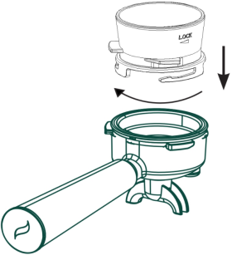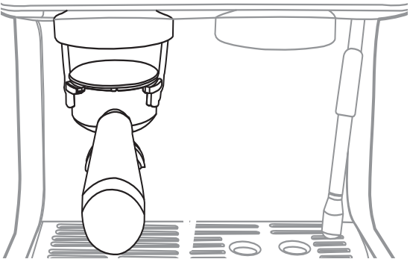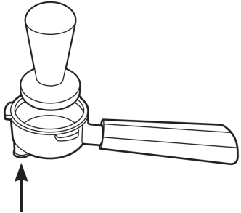
- Distribute the pre-ground coffee evenly and press lightly with the presser.
- Correct pressing of the pre-ground coffee is essential to obtain a good espresso.If you press too firmly, the coffee will be delivered slowly and will be strong. If you press too lightly, the coffee will be delivered quickly and will be weak.
- Remove any excess coffee from the rim of the filter holder and attach the filter holder to the appliance. To attach correctly, align the filter holder handle with the UNLOCK symbol,attach the filter holder and rotate the handle towards the right until aligned with the LOCK symbol.
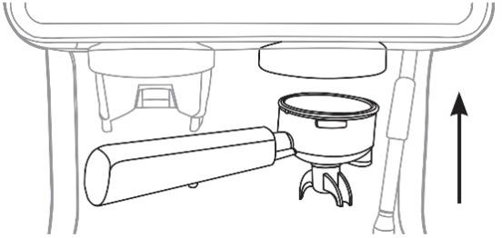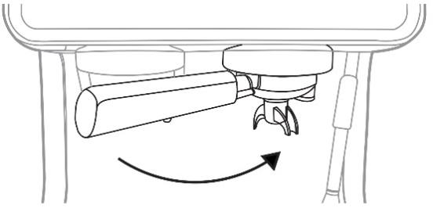
- Place the cup or cups under the filter holder spouts.
- Make sure the lights corresponding to the coffee buttons are on, then press the
1-CUP or 2-CUP coffee button. The appliance proceeds to make the coffee and delivery is interrupted automatically.
- To remove the filter holder, turn the handle from right (LOCK) to left (UNLOCK).

 Danger of burns!
To avoid splashes, never remove the filter holder while the appliance is delivering coffee. Always wait for a few seconds after delivery.
- HOW TO MAKE CAPPUCCINO
- Prepare the espresso coffees as described in the previous sections, using sufficiently large cups.
- Press the STEAM button and the indicator light on.
- In the meantime, fill a recipient with about 100 grams of milk for each cappuccino to be prepared.For a denser more even froth, you must use whole milk at refrigerator temperature (about 5°C). In choosing the size of the recipient, bear in mind that the milk doubles or triples in volume.
- Put an empty container under the cappuccino maker and open the dial for a few seconds to eliminate any air left in the circuit.Close the dial again.
- Place the recipient containing the milk under the cappuccino maker.
- Immerse the cappuccino maker in the milk container. Never immerse the black ring . Turn the dial to the STEAM position. Steam is delivered from the cappuccino maker, giving the milk a creamy frothy appearance . To obtain a creamier froth, immerse the cappuccino maker in the milk and rotate the container with slow upward movements.
- When the required temperature (the ideal is 60°C) and froth density is reached,interrupt steam delivery by turning the steam dial to OFF position.
- Pour the frothed milk into the cups containing the espresso coffee prepared previously, the cappuccino is ready. Sweeten to taste and if desired, sprinkle the froth with a little cocoa powder.

 Please note:
- To prepare more than one cappuccino, first make all the coffees then at the end prepare the frothed milk for all the cappuccinos.
- To make coffee again immediately after frothing milk, the boiler must first be cooled ,otherwise the coffee will be burnt, so we suggest to press 1-CUP or 2-CUP button and release few high temperature water before make another cup of coffee.
- Be careful about the splashing hot water and steam released from the cappuccino maker pipe.
- When the steam button light up,you can not choose the 1-CUP or 2-CUP function,press the steam button again to cancel the steam mode.

Do not deliver steam for more than 60 seconds.

- Dial In Instructions
Dial in your machine by altering the different parameters to create the best tasting shot
for a particular coffee choice. Once the machine is “dialed-in”, you can create repeatable
results with ease.
- Select a desired grind size. (Setting 5-9 is the recommended starting point)
- Grind and weigh coffee for an espresso shot (16-18g worth of grounds for double, 9-12g for single). Directions on how to change the grind function are on page 9.
- Gently tap the sides of the portafilter to even out the coffee distribution.
- Tamp firmly to create a level surface, wipe the excess coffee grounds from the edges of
the portafilter and brew your espresso.
- Weigh the liquid espresso to find the brew ratio. Brew ratios are personal preference, but can be used to guide your taste as well.
• Brew ratio is defined as the ratio of coffee grounds in the portafilter to liquid espresso.
• Example: If 18g of coffee grounds yields 36g of liquid espresso, this is a 1:2 brew ratio.

Ristretto | 1:1 to 1:2
Espresso | 1:1 to 1:2
Lungo | 1:3 to 1:4

• The water volume can be increased or decreased to alter the brew ratio. Directions on how to do so are on page 5 of the manual.
- Aim for a brew time between 20-40 seconds for your shot.
• Time is recorded from when the function starts to when espresso stops dispensing into cup.
• If time is below range, use a finer setting or larger water volume.
• If time is above range, use a coarser setting or lesser water volume.
- If brew time is within range, taste the espresso.

Sour shot | Use a finer setting or larger wate volume.
Bitter shot | Use a coarser setting or lesser water volume.
These are guidelines, adjust per preference.

Other Tips
• It is important to only change one parameter at a time, and keep other variables
constant through this process.
• If you prefer a milk-based espresso drink, taste the espresso with your milk
choice as it will affect the flavor profile.

- Resetting the machine
If you want to cancel the quantity of grinding time ,coffee and hot water, please proceed as follows :
- Plug in.
- Press 1-CUP and 2-CUP simultaneously in 3 seconds(do not release).
- The machine with a beep sound and the LED display shows ‘000’, indicating that the quantity of coffee has been reset.

CLEANING

Important!
- Do not use solvents, abrasive detergents or alcohol to clean the coffee machine.
- Do not use metal objects to remove encrustations or coffee deposits as they could scratch metal or plastic surfaces.
- If the appliance is not used for more than one week, before using it again, we strongly recommend you perform a rinse cycle as described in section “7. first use”.

 Danger!
- While cleaning, never immerse the coffee maker in water. It is an electrical appliance.

12.1 Descale

Important: In order to ensure the pure taste of coffee, please descale the coffee machine after 2-3 months of use.
- Ensure that the descaling product is suitable for coffee machines.Or use the citric acid (100 water:3 citric acid) instead of the descaling product.
- Fill the water tank with the descaling solution.
- Place a large container on the drip tray.
- Plug in the machine,long press the 2-CUP button for 3 seconds,release the button after beep up one sound.The left LED display show “P1” and the right LED display show nothing,the power button and 2-CUP button are lighting,then press the 2-CUP button,start the Descale mode.
- The Descale mode will last for 2 minutes,after finished,the machine will be power off automatically.You can stop the Descale mode anytime by pressing the POWER button.
- Rinse the water tank and fill with water.
- Operate as if making coffee and flush water through the machine.This will remove any traces of the descaling solution.
- Store the cleaned coffee machine unplugged with no coffee in the filter and with the water tank empty.

12.2 Cleaning the drip tray

Important! Please pay attention to the amount of water in the drip tray. Before water overflows from the cup tray, the drip tray must be emptied and cleaned otherwise the water may overflow the edge and damage the appliance, the surface it rests on or the surrounding area. We suggest to clean it every time when you using. When clean the drip tray, please proceed as follow :
- Remove the drip tray and cup tray.
- Separate the cup tray and drip tray, clean them with a soft damp cloth, then reassemble them.
- Dry and put it back in the machine.

12.3 Cleaning the coffee filters

Clean the coffee filters regularly:
- Rinse the filters under running water.
- Make sure the holes are not blocked. If necessary, clean with a pin.

12.4 Other cleaning operations
- Do not use solvents or abrasive detergents to clean the coffee maker. Use a soft damp cloth only.
- Clean the filter holder cup.

12.5 Cleaning the water tank
Clean the water tank regularly (about once a month) with a damp cloth and a little mild washing up liquid.

12.6 Cleaning the cappuccino maker

Important:

For hygiene reasons, the cappuccino maker should always be cleaned after use. Proceed as follow:

Turn the steam dial to deliver a little steam for a few seconds. This causes the cappuccino maker to discharge any milk left inside.
- Press the ON/OFF button to turn the appliance off.
- Ensure that the Froth Nozzle is cool before cleaning. Pull the Froth Nozzle off the Steam Wand and wash under running water to remove any milk residue. Risk of burns.
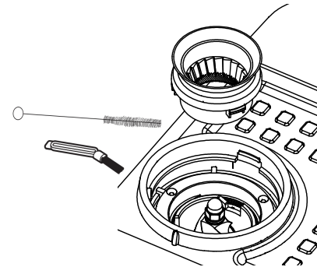
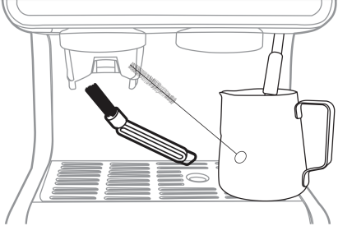

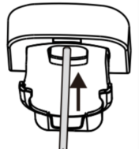
12.7 Cleaning the Grinder
Be sure to place a cup or container under the grinder
when completing this process to collect loose grounds
of coffee. It is recommended to clean the grinder at
least once a week.

- Remove the bean hopper from the espresso machine.
- Rotate to unlock and pull out the outer burr.
- Use the brushes provided to wipe away any grounds from
the grinder. Make sure to clean the grinder from top and
bottom of the grinder chute.
- Place the outer burr back into the machine.
- Place the bean hopper back into place.
NOTE: Do not use hands to wipe away grounds, only
use the brushes.

Danger!
While cleaning, never immerse the coffee maker in water.
It is an electrical appliance.

- COMMON TROUBLE SHOOTING

Problem | Cause | Solution
No espresso coffee  is delivered | Residual air inside | Open the steam knob after heating up as described in section ‘7.FIRST USE’
No espresso coffee  is delivered | No water in the tank | Fill the tank
No espresso coffee  is delivered | The holes in the filter holder are blocked | Clean the filter holder spout holes
No espresso coffee  is delivered | The filter is blocked | Clean as described in section “12.3 Cleaning the coffee filters”
No espresso coffee  is delivered | The tank has been inserted incorrectly and the valves on the bottom are not open | Press the tank down lightly to open the valves on the bottom
No espresso coffee  is delivered | Limescale in the water circuit | Descale as described in section “12.1 Descale”
The espresso coffee drips from the edges of the filter holder rather than the holes | The filter holder has been inserted incorrectly or is dirty | Attach the filter holder correctly and rotate firmly as far as it will go
 | The holes in the filter holder spouts are blocked | Clean the filter holder spout holes
 | The filter is blocked | Clean as described in section “12.3 Cleaning the coffee filters”
The filter holder cannot be attached  to the appliance | Too much coffee has been placed in the filter | Use the measure supplied and make sure you are using the correct filter for the type of preparation
The appliance will not make any coffee and the function button lights flash for a few seconds. | No water in the tank | Fill the tank with water
 | The tank has been inserted incorrectly and the valves on the bottom are not open | Press the tank down lightly to open the valves on the bottom
 | The filter is blocked | Clean as described in section “12.3 Cleaning the coffee filters”
 | Limescale in the water circuit | Descale as described in section “12.1 Descale”
The coffee froth is too light (delivered from the spout too fast) | The pre-ground coffee is not pressed down firmly enough | Press the pre-ground coffee more firmly
 | There is not enough pre-ground coffee | Increase the quantity of pre-ground coffee
 | The pre-ground coffee is too coarse | Use only pre-ground coffee for espresso coffee makers
 | The wrong type of pre-ground coffee is being used | Change the type of pre-ground coffee

The coffee froth is too dark (delivered from the spout too slowly) | The pre-ground coffee is pressed down too firmly | Press the coffee down less firmly
 | There is not enough pre-ground coffee | Reduce the quantity of pre-ground coffee
 | The filter is blocked | Clean as described in section “12.3 Cleaning the coffee filters”
 | The pre-ground coffee is too fine | Use only pre-ground coffee for espresso coffee makers
 | The pre-ground coffee is too fine or damp | Use pre-ground coffee for espresso coffee makers only and make sure it is not too damp
 | Limescale in the water circuit | Descale as described in section “12.1 Descale”
No milk froth is formed when making cappuccino | Milk not cold enough | Always use milk at refrigerator temperature （5°C)
No milk froth is formed when making cappuccino | Cappuccino maker dirty | Clean as described in section “12.6 Cleaning the cappuccino maker after using”
No milk froth is formed when making cappuccino | Limescale in the water circuit | Descale as described in section “12.1 Descale”
The steam come out from the coffee spout. | The steam button is still ON. | Interrupt steam delivery by turning off the steam button first.Then turn off the the steam dial to OFF position.
Grinder is making a  very loud sharp noise | There are foreign objects in the grinder. | Clear the grinder per the directions in the Care and Cleaning section.
The appliance does not function and all function button lights flash |  | Disconnect the appliance immediately and contact Customer Services

Please read the following instructions and keep them on hand for later reference .

